**Dependent Sources**

**Voltage Controlled Voltage Source**

Command: Ename OUT+ OUT- IN+ IN- Gain_Value

**Voltage Controlled Current Source**

Command: Gname OUT+ OUT- IN+ IN- Gain_Value

**Current Controlled Voltage Source**

Command: Hname OUT+ OUT- V_Control Gain_Value

**Current Controlled Current Source**

Command: Fname OUT+ OUT- V_Control Gain_Value

* **OUT+** and **OUT-** are the positive and negative terminals of the dependent source, respectively.
* **IN+** and **IN-** are the positive and negative terminals of the controlling voltage source, respectively.
* **V_Control** is the zero value voltage source used to measure the controlling current (the positive current flows into the positive terminal of the controlling voltage source! Remember!).

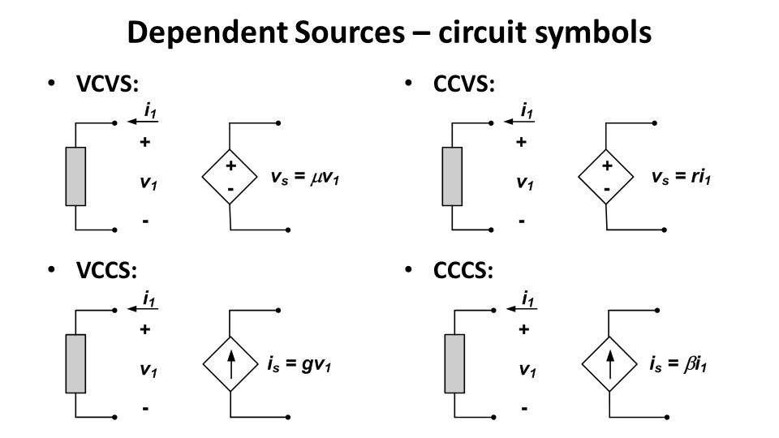

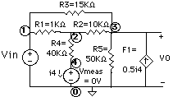

**Current Controlled Current Source Example**

F1 0 3 V_Meas 0.5

V_Meas 4 0 DC 0